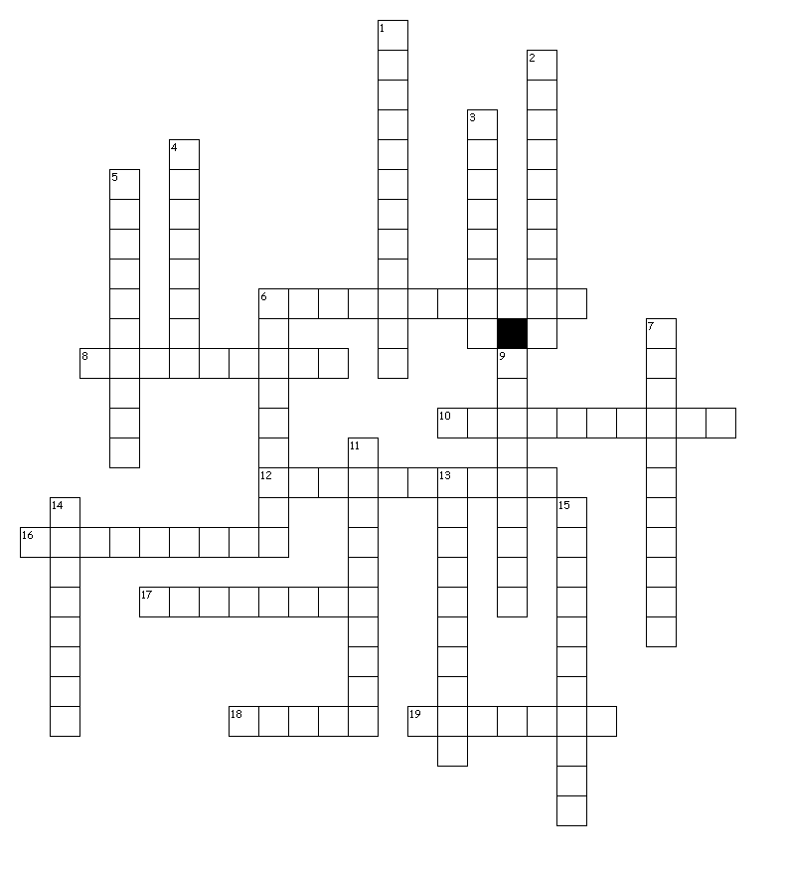

**Down**

1. people + record + characteristic of

2. all + know + full of

3. earth + measure

4. start + kill

5. with + know + full of

6. life + writing

7. ancient + study of

9. life + circle

11. before + war

13. again + break + characteristic of

14. distance + write

15. not + with + knowledge + full of

**Roots Unit #4**

Build-A-Word

Name: ______________________________

Period: 1 4 5 7

19. ancient + characteristic of

**Across**

6. fight + full of

8. birth + study of

10. earth + shape + characteristic of

12. sound + record

16. people + rule + result of

17. break + qualities of

18. not + to arm

19. ancient + characteristic of