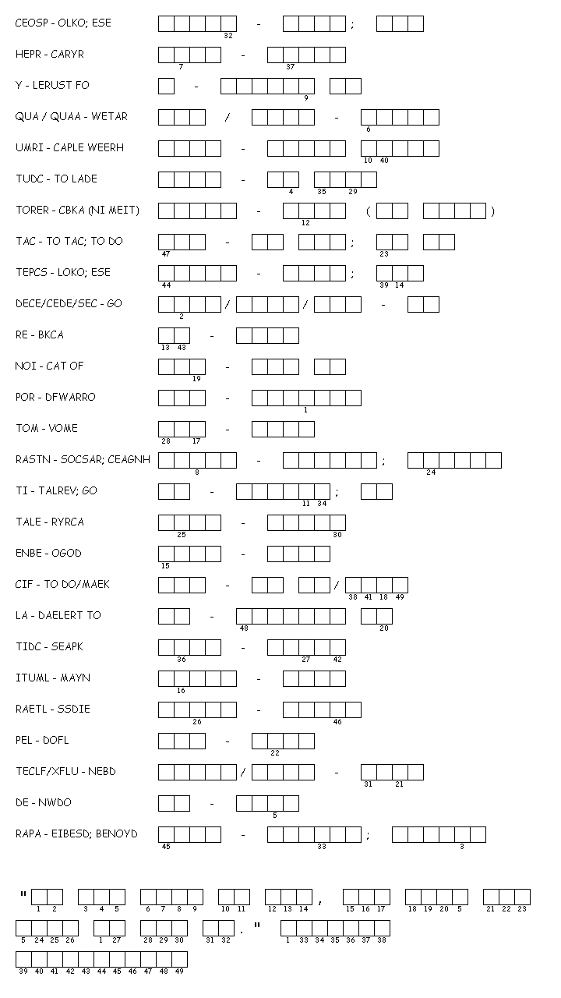

**Roots Unit #3 Unscramble Roots and Meanings**

Name: __________________ Period: 1 4 5 7