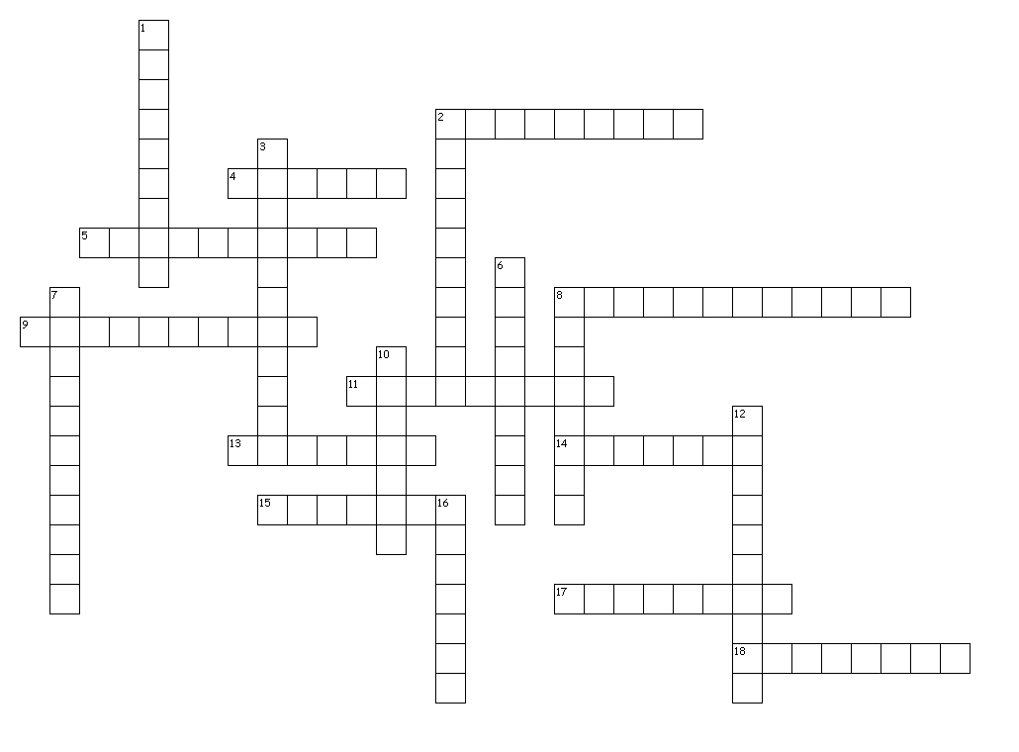

**Unit #3 Roots** Build-A-Word Crossword

**Across**

2. around+look;see

4. back+ go

5.beyond+standard/usual+related to

8. many+sides+related to

9. back+look;see

11. change+carry

13. back;again+bend

14. forward+move+e

15. down+bend

17. water+to lead

18. water+place where

**Down**

1. around+carry+result of

2. forward+go+act of

3. back+to act + quality of

6. beside+law+related to

7. good+dict+ion

8. many+fold

10. forward+go

12. good+to do+related to 16. across+travel;go