“The Tell-Tale Heart” Trial Directions and Format

Roles: Insert the names of the students who will be responsible for upholding each role of the trial:

Judge: ______________________________
Defendant Lawyer: ______________________ Plaintive Lawyer: ________________________
Narrator: _______________________________ Police Officers: __________________________
- - - - - - - - - - - - - - - - - - - - - - - - - - - - - - - - - - - - - - - - - - -
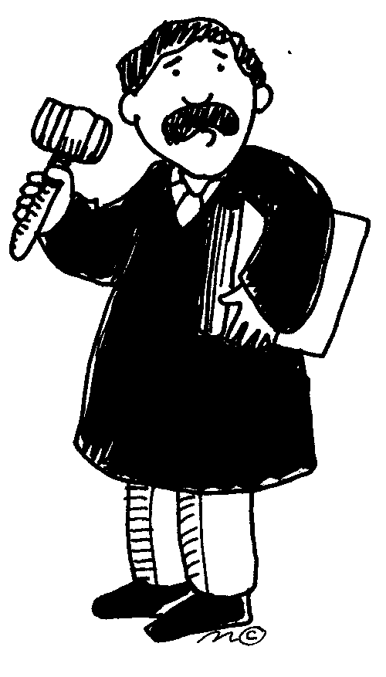
Judge Job: Needs to be a leader and someone helps to organize people and defuse conflict
- Leader of the group to help complete the project task
- Keep everyone to the strict order and time of the schedule
- Delivering the verdict

- Defendant opening statement: (2 minutes)
- Plaintive opening statement: (2 minutes)

- Questioning of narrator by defendant lawyer: (2 minutes)
- Questioning of narrator by plaintive lawyer: (2 minutes)

- Questioning of police officer by defendant lawyer: (2 minutes)
- Questioning of police officers by plaintive lawyer: (2 minutes)

- Defendant closing statement: (1 minute)
- Plaintive closing statement: (I minute)

- Reading of the verdict by the judge
- - - - - - - - - - - - - - - - - - - - - - - - - - - - - - - - - - - - - - - - - - -
Defendant Lawyer: Is good at looking at evidence and making a convincing argument. Needs to act very serious and direct.
- Plan and deliver an opening statement that the narrator is innocent because he is insane
- Prepare a series of questions for the narrator
- Prepare a series of questions for the police officer
- Plan and deliver a closing statement narrator is innocent because he is insane
- - - - - - - - - - - - - - - - - - - - - - - - - - - - - - - - - - - - - - - - - - -
Narrator: A dramatic actor who is willing to take on a character’s persona. Needs to have a good understanding of the text and the narrator’s character.
- Recount the events of the evening
- Act like the narrator
- - - - - - - - - - - - - - - - - - - - - - - - - - - - - - - - - - - - - - - - - - -
Plaintive Lawyer: Is good at presenting facts and thinking of questions that trick people into giving explanations to prove a point. Likes to argue.
- Plan and deliver an opening statement that the narrator is guilty
- Prepare a series of questions for the narrator
- Prepare a series of questions for the police officer
- Plan and deliver a closing statement to show that the narrator is guilty
- - - - - - - - - - - - - - - - - - - - - - - - - - - - - - - - - - - - - - - - - - -
Police Officer: Understand the events of the passage and can recount them in sequential order.
- Recount the events of the evening
- Act like the police officer

Name: _____________________________________ Period: 1 4 5 7

Judge’s Worksheet
Notes from Parts of the Trial
- Defendant opening statement: (2 minutes) “May the defendant’s attorney please give his/her opening statement”
NOTES:

- Plaintive opening statement: (2 minutes) “Thank you. May the plaintiff’s attorney please give his/her opening statement”
NOTES:

- Questioning of narrator by defendant lawyer: (2 minutes) “Thank you. Will the narrator please approach the bench for questioning? Counselor, please being your questioning”
NOTES:

- Questioning of narrator by plaintive lawyer: (2 minutes) “Thank you. Counselor, please have a seat. Counselor, you may now begin your questioning of the defendant.”
NOTES:

- Questioning of police officer by defendant lawyer: (2 minutes) “Thank you. Defendant you may return to your seat. Officer, please approach the bench for questioning. Councilor, you may begin you line of questioning.”
NOTES:

- Questioning of police officers by plaintive lawyer: (2 minutes) “Thank you. Counselor, please have a seat. Counselor, you may now begin your questioning of the plaintive.”
NOTES:

- Plaintive closing statement: (1 minute) “Thank you. Counselor, you may give your closing statement on the behalf of the defendant”
NOTES:

- Defendant closing statement: (1 minute) “Thank you. Officer, you may return to your seat. Counselor, you may being your closing statement on the behalf of the plaintive.”
NOTES:

- Reading of the verdict by the judge: “In the case of Narrator vs. Police Officer with the charges of man slaughter of the narrator’s neighbor, I find the defendant . . .
(Circle one): Guilty Not Guilty

WHY: On account that ______________________________________________________________ ________________________________________________________________________________________________________________________________________________________________________
Name: _____________________________________ Period: 1 4 5 7

Defendant’s Lawyer Worksheet
Opening Statement:
- Something catchy and engaging
- Clear stance that the defendant is NOT guilty and why
- Why others/judge should agree

________________________________________________________________________________________________________________________________________________________________________________________________________________________________________________________________________________________________________________________________________________________________________________________________________________________________________________________________________________________________________________________
____________________________________________________________________________________
____________________________________________________________________________________
Questions for Narrator:
Questions: | Expected Answers: | Why Asking / What you hope to gain by asking this question:

Questions for Police Officer:
Questions: | Expected Answers: | Why Asking / What you hope to gain by asking this question:

Closing Statement:
- Summarize the points of the trial that show that the defendant is NOT guilty
- Give a clear closing stance that the narrator is NOT guilty
________________________________________________________________________________________________________________________________________________________________________________________________________________________________________________________________________________________________________________________________________________________________________________________________________________________________________________________________________________________________________________________
____________________________________________________________________________________
Name: _____________________________________ Period: 1 4 5 7

Plaintiff’s Lawyer Worksheet
Opening Statement:
- Something catchy and engaging
- Clear stance that the defendant IS guilty and why
- Why others/judge should agree

________________________________________________________________________________________________________________________________________________________________________________________________________________________________________________________________________________________________________________________________________________________________________________________________________________________________________________________________________________________________________________________
____________________________________________________________________________________
____________________________________________________________________________________
Questions for Narrator:
Questions: | Expected Answers: | Why Asking / What you hope to gain by asking this question:

Questions for Police Officer:
Questions: | Expected Answers: | Why Asking / What you hope to gain by asking this question:

Closing Statement:
- Summarize the points of the trial that show that the defendant IS guilty
- Give a clear closing stance that the narrator IS guilty
________________________________________________________________________________________________________________________________________________________________________________________________________________________________________________________________________________________________________________________________________________________________________________________________________________________________________________________________________________________________________________________
____________________________________________________________________________________
Name: _____________________________________ Period: 1 4 5 7

Narrator’s Worksheet

Dialogue (both internal and external) | Character Trait Revealed

Sequence of events in the passage through the perspective of the narrator:

1.
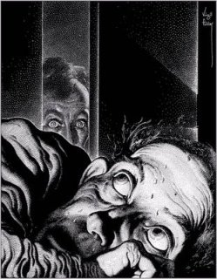
2.
3.
4.
5.
6.
7.
8.
9.
10.
Name: _____________________________________ Period: 1 4 5 7

Police Officer’s Worksheet

Dialogue (both internal and external) | Character Trait Revealed

Sequence of events in the passage through the perspective of the police officer:

1.
2.
3.
4.
5.
6.
7.
8.
9.
10.

