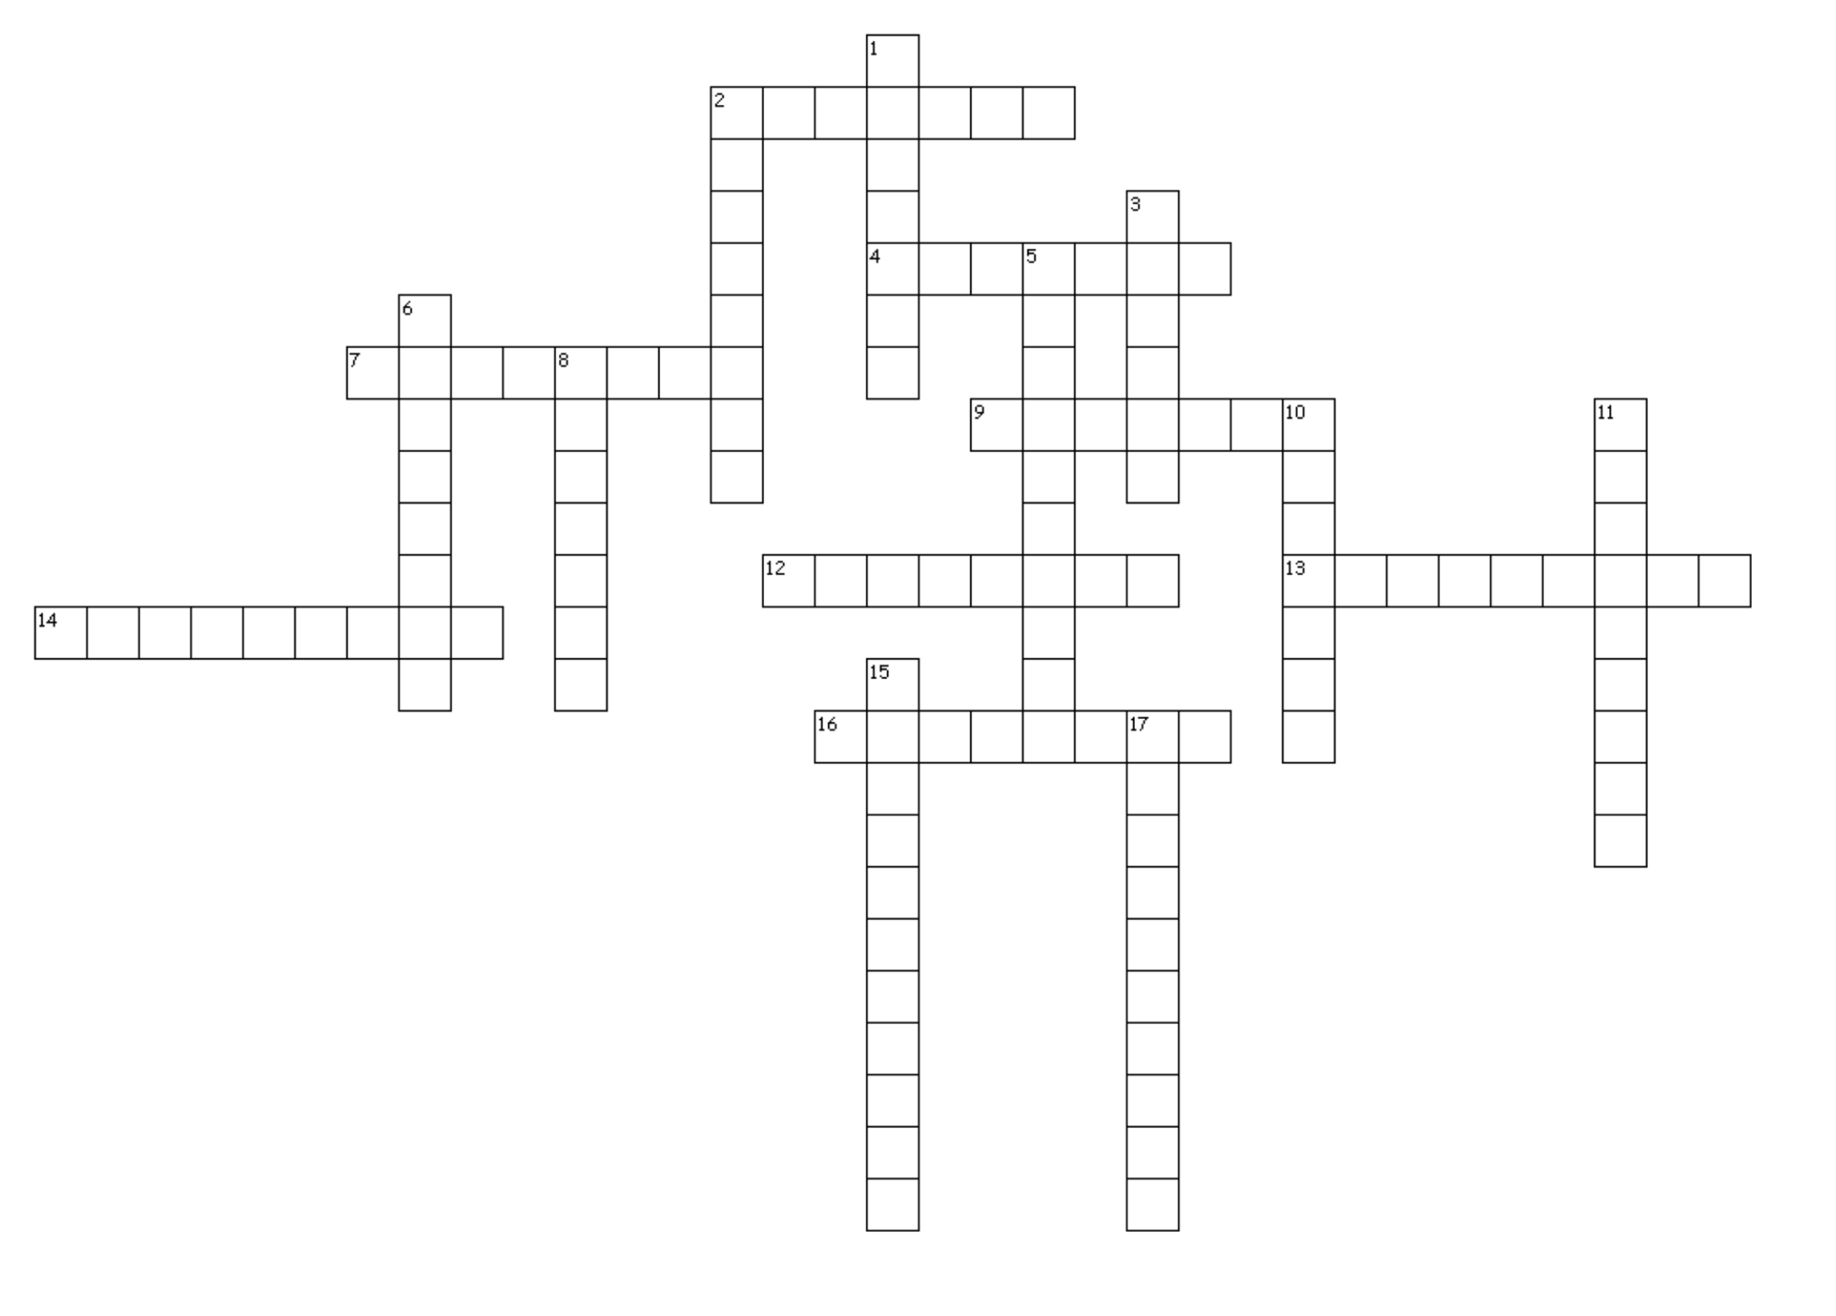

**ACROSS**

2. same + name

4. not; without + faith + one who

7. together + draw

9. forth + voice

12. two + name + characteristic of

13. again + water + to make

14. down + water + to make

16. belief + characteristic of

**DOWN**

1. together + faith

2. same + feeling

3. again; back + life

5. in; into + believe + able to

6. name + to make

8. again + turn

10. out + draw; pull

11. life + full of

15. not + back; again + voice

17. together + turn; roll

Name: ________________________

Period: 1 4 5 7

Roots Unit #6

Build-A-Word

Crossword Puzzle