Unit #6 Roots and Meanings Unscramble
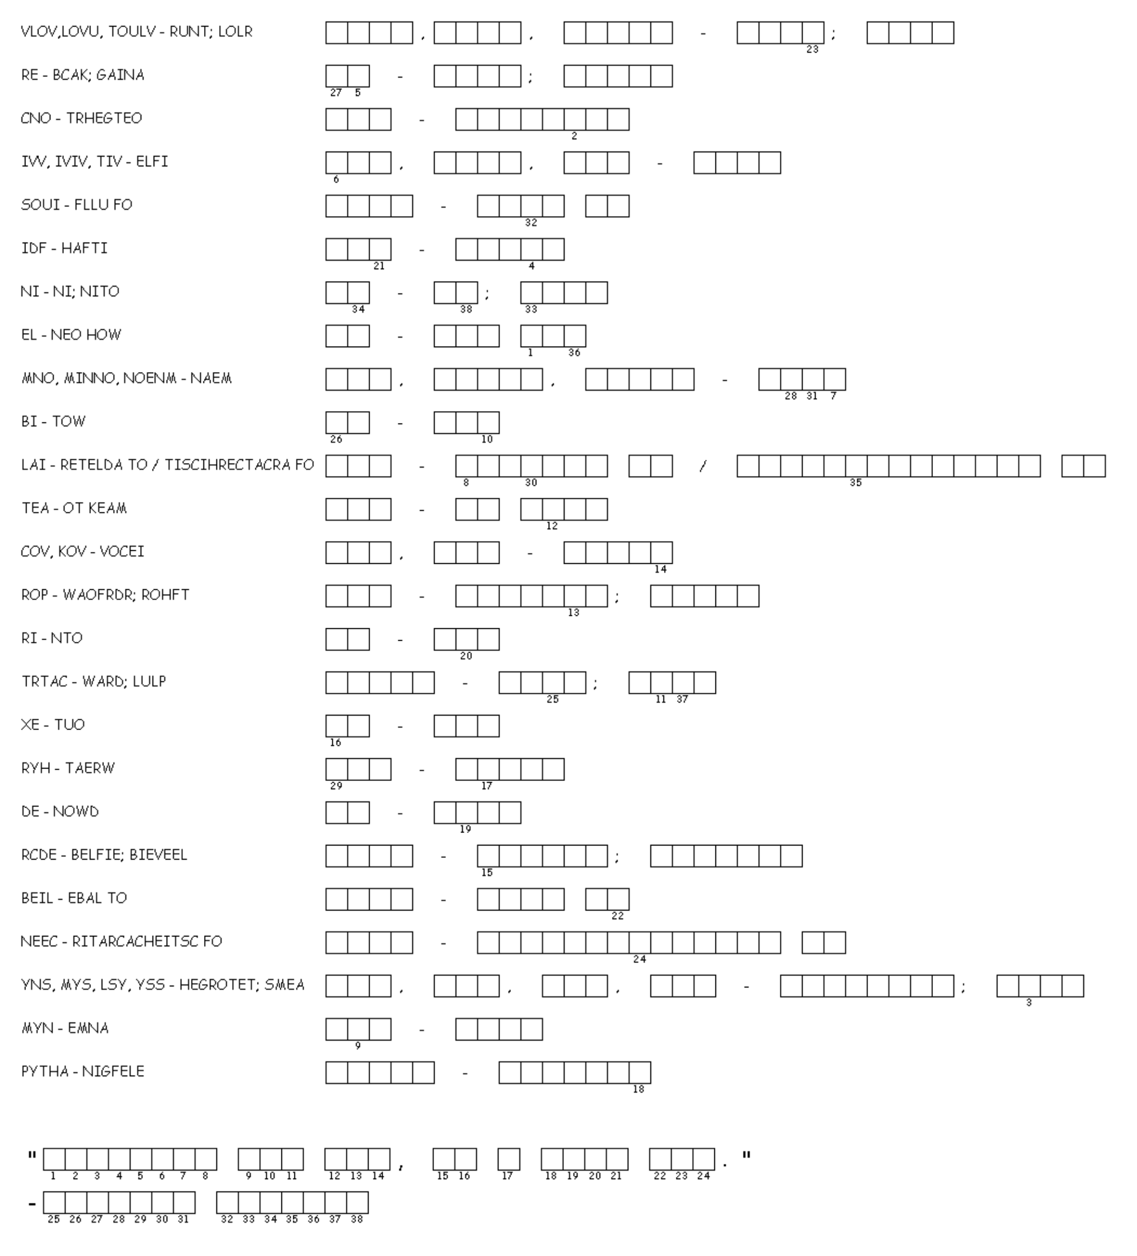
Unscramble the root and their meaning. Then use the number code to decipher the hidden code.

