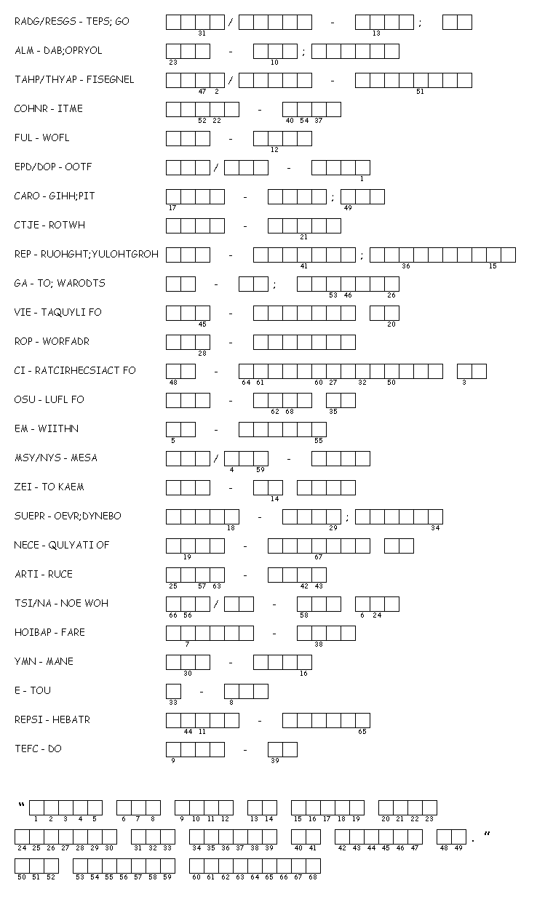

**Roots Unit #5: Word Scramble Name_______________________**

DIRECTIONS: Unscramble to term – meaning and then use the numbers to decipher the hidden message at the bottom