Fixed Mindset vs. Growth Mindset: Which One Are You?

Here is an excerpt from an article about Carol Dweck, a professor of psychology at Stanford University:

“Through more than three decades of systematic research, [Carol Dweck] has been figuring out answers to why some people achieve their potential while equally talented others don’t—why some become Muhammad Ali and others Mike Tyson. The key, she found, isn’t ability; it’s whether you look at ability as something inherent that needs to be demonstrated or as something that can be developed.”

To anyone who is into personal growth and self-improvement, this seems obvious. But clearly, it is not obvious to everybody: look at this diagram by Nigel Holmes representing the two types of mindsets and I’ll sure you’ll recognize the attitudes of many people you know.

Fixed Mindset
Let’s have a look, starting with the Fixed Mindset side:
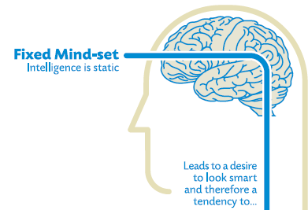
People who hold these beliefs think that “they are the way they are”, but that doesn’t mean that they have less of a desire for a positive self-image than anyone else. So of course they want to perform well and look smart. But to achieve these goals…
By definition, a challenge is hard and success is not assured, so rather than risk failing and negatively impacting their self-image, they will often avoid challenges and stick to what they know they can do well.
Same with obstacles. The difference here, as I see it, is that challenges are things that you can decide to do while obstacles are external forces that get in your way.
What’s the point of working hard and making efforts if afterwards you are still on square one? If your worldview tells you that effort is an unpleasant thing that doesn’t really pay dividends, then the smart thing to do is to avoid it as much as possible.
Useful negative feedback is ignored in the best of cases, and taken as an insult the rest of the time. The Fixed Mindset logically leads you to believe that any criticism of your capabilities is criticism of you. This usually discourages the people around and after a while they stop giving any negative feedback, further isolating the person from external influences that could generate some change.
The success of others is seen as a benchmark against which the person looks bad. Usually when others succeed, people with a Fixed Mindset will try to convince themselves and the people around them that the success was due to either luck (after all, almost everything is due to luck in the Fixed Mindset world) or objectionable actions. In some cases, they will even try to tarnish the success of others by bringing up things that are completely unrelated (“Yes, but did you know about his…”).
As a result, they don’t reach their full potential and their beliefs feed on themselves: They don’t change or improve much with time, if at all, and so to them this confirms that “they are as they are”.

Growth Mindset
Let’s now look at the Growth Mindset:
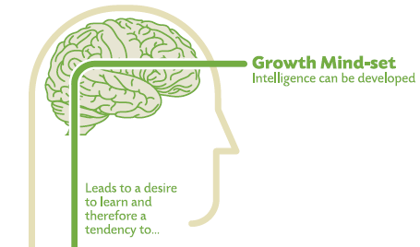
People who hold the Growth Mindset believe that intelligence can be developed, that the brain is like a muscle that can be trained. This leads to the desire to improve.
And how do you improve? First, you embrace challenges, because you know that you’ll come out stronger on the other side.
Similarly, obstacles – external setbacks – do not discourage you. Your self-image is not tied to your success and how you will look to others; failure is an opportunity to learn, and so whatever happens you win.
Effort is seen not as something useless to be avoid but as necessary to grow and master useful skills.
Criticism and negative feedback are sources of information. That doesn’t mean that all criticism is worth integrating or that nothing is never taken personally, but at least the Growth Mindset individual knowns that he or she can change and improve, so the negative feedback is not perceived as being directly about them as a person, but rather about their current abilities.
The success of others is seen as a source of inspiration and information. To Growth Mindset individuals, success is not seen as azero-sum game.
And so, Growth Mindset individuals will improve and this will create a positive feedback loops that encourages them to keep learning and improving.

What Now
The good news – especially if you just recognized yourself as being someone who holds the Fixed Mindset worldview – is that it is possible to change from one to the other. In fact, I think this should be taught to all children.
What’s more, Dweck has shown that people can learn to adopt the latter belief and make dramatic strides in performance. [...]

“The most dramatic proof comes from a recent study by Dweck and Lisa Sorich Blackwell of low-achieving seventh graders. All students participated in sessions on study skills, the brain and the like; in addition, one group attended a neutral session on memory while the other learned that intelligence, like a muscle, grows stronger through exercise. Training students to adopt a growth mind-set about intelligence had a catalytic effect on motivation and math grades; students in the control group showed no improvement despite all the other interventions.
‘Study skills and learning skills are inert until they’re powered by an active ingredient,’ Dweck explains. Students may know how to study, but won’t want to if they believe their efforts are futile. ‘If you target that belief, you can see more benefit than you have any reason to hope for.’”
Does the Fixed vs. Growth Mindset theory fits with your personal experience? Does it describe well the people around you?

Students' View of Intelligence Can Help Grades
by MICHELLE TRUDEAU

(1)A new study in the scientific journalChild Development shows that if you teach students that their intelligence can grow and increase, they do better in school.
(2) All children develop a belief about their own intelligence, according to research psychologist Carol Dweck from Stanford University.
"Some students start thinking of their intelligence as something fixed, as carved in stone," Dweck says. "They worry about, 'Do I have enough? Don't I have enough?'"
(3) Dweck calls this a "fixed mindset" of intelligence.
(4) "Other children think intelligence is something you can develop your whole life," she says. "You can learn. You can stretch. You can keep mastering new things."
(5) She calls this a "growth mindset" of intelligence.
(6) Dweck wondered whether a child's belief about intelligence has anything to do with academic success. So, first, she looked at several hundred students going into seventh grade, and assessed which students believed their intelligence was unchangeable, and which children believed their intelligence could grow. Then she looked at their math grades over the next two years.
(7) "We saw among those with the growth mindset steadily increasing math grades over the two years," she says. But that wasn't the case for those with the so-called "fixed mindset." They showed a decrease in their math grades.
(8) This led Dweck and her colleague, Lisa Blackwell, from Columbia University to ask another question.
(9)"If we gave students a growth mindset, if we taught them how to think about their intelligence, would that benefit their grades?" Dweck wondered.
(10) So, about 100 seventh graders, all doing poorly in math, were randomly assigned to workshops on good study skills. One workshop gave lessons on how to study well. The other taught about the expanding nature of intelligence and the brain.
(11) The students in the latter group "learned that the brain actually forms new connections every time you learn something new, and that over time, this makes you smarter."
(12) Basically, the students were given a mini-neuroscience course on how the brain works. By the end of the semester, the group of kids who had been taught that the brain can grow smarter, had significantly better math grades than the other group.
(13) "When they studied, they thought about those neurons forming new connections," Dweck says. "When they worked hard in school, they actually visualized how their brain was growing."
(14) Dweck says this new mindset changed the kids' attitude toward learning and their willingness to put forth effort. Duke University psychologist, Steven Asher, agrees. Teaching children that they're in charge of their own intellectual growth motivates a child to work hard, he says.
(15) "If you think about a child who's coping with an especially challenging task, I don't think there's anything better in the world than that child hearing from a parent or from a teacher the words, 'You'll get there.' And that, I think, is the spirit of what this is about."
(16) Dweck's latest book, Mindset: The New Psychology of Success, gives parents and teachers specific ways to teach the growth mindset of intelligence to children.

