Dictionary Assignment Requirements
DIRECTIONS: You and the others at your table to collaborate to create a Tom Sawyer dictionary.
- Each person at your group will do 5-6 letters, so you have all letters represented when you compile your entries. (each letter entry is 1 point and the cover is 2 points = 25 point assignment)
- For each letter, you need 2-5 words or phrases.
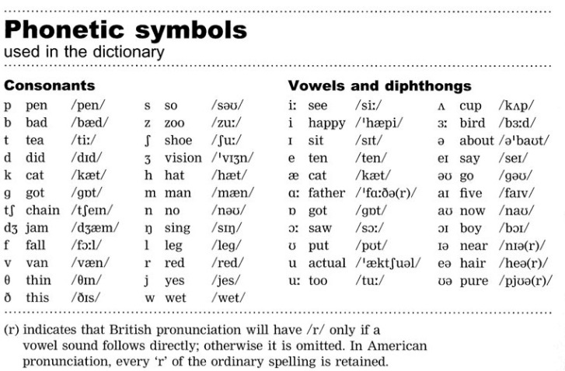
- One picture per letter page
- For each word or phrase you need:
  - The word
  - The (pronunciation) using phonetic symbols
  - The part of speech abbreviation i.e. n. v. adj. adv.
  - The definition and any alternate definitions 1.numbered
  - Synonyms Syn:
  - The textual Sentence: where this word or phrase exist in the novel and the page number indicated at the end (Twain #)
    - For phrases, you can be a bit more creative with the definition and relate it to the novel if need be (i.e. Lick ( ) v. 1.to hit or mark something; or what would happen to Tom should he get caught by Aunt Polly)
SAMPLE ENTRY:
Lick /lIk/ v. 1. To strike or hit with force out of anger 2. To make a mark or leave a make 3. Touch
Syn: hit, strike, touch, graze.
Sentence: “’I could lick you with one hand tied behind me, if I wanted to. ‘” (Twain 5)

Dictionary Assignment Requirements
DIRECTIONS: You and the others at your table to collaborate to create a Tom Sawyer dictionary.
- Each person at your group will do 5-6 letters, so you have all letters represented when you compile your entries. (each letter entry is 1 point and the cover is 2 points = 25 point assignment)
- For each letter, you need 2-5 words or phrases.
- One picture per letter page
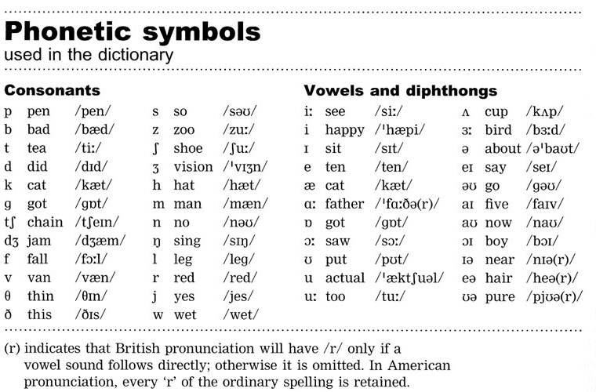
- For each word or phrase you need:
  - The word
  - The (pronunciation) using phonetic symbols
  - The part of speech abbreviation i.e. n. v. adj. adv.
  - The definition and any alternate definitions 1.numbered
  - Synonyms Syn:
  - The textual Sentence: where this word or phrase exist in the novel and the page number indicated at the end (Twain #)
    - For phrases, you can be a bit more creative with the definition and relate it to the novel if need be (i.e. 1.to hit or mark something 2.what would happen to Tom should he get caught by Aunt Polly)

SAMPLE ENTRY:
Lick /lIk/ v. 1. To strike or hit with force out of anger 2. To make a mark or leave a make 3. Touch
Syn: hit, strike, touch, graze.
Sentence: “’I could lick you with one hand tied behind me, if I wanted to. ‘” (Twain 5)

