Unit #1: Build-A-Word Practice
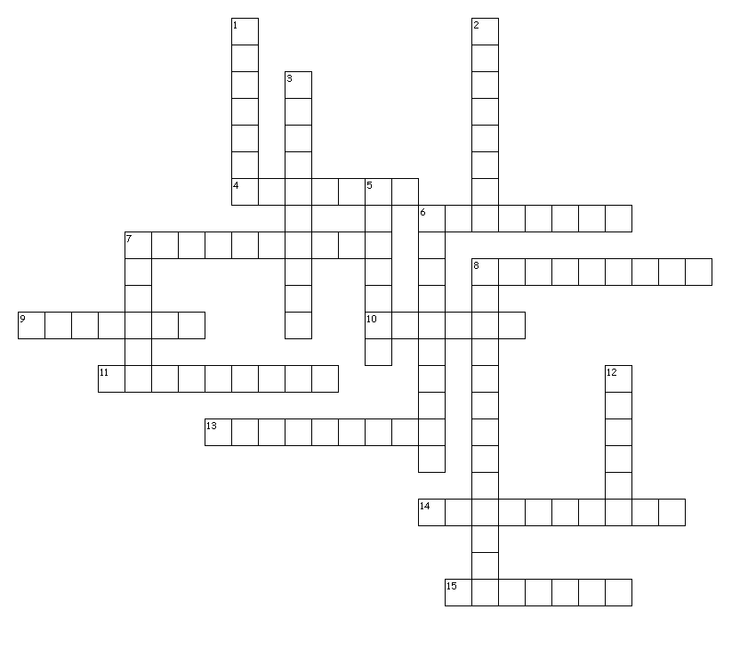

Name: _________________________________________

Period: 1 4 5 7

Across
4. away + break
6. before + judge
7. small + see + characteristic of
8. between + cut 9. without + god + one who
10. down + move
11. between + break
13. in; into + lead
14. against + life + characteristic of
15. without + laws

Down
1. down + climb
2. after + place; put
3. against + society + related to
5. before + go
6. after + terror
7. middle + not; without
8. in + look; see + act of
12. apart + turn

