Are you a Genius?
“You are a genius, and the world expects your contribution.”

What is Genius Hour?
Also known as "Passion Projects" or "Personal Inquiry Time," Genius Hour is for you! Every week students will have self-directed time to pursue their passions, choose what they will master, inquire about their own curiosities. Over the course of Genius Hour you will choose your passion, guide your learning and develop a project of your choosing. Along the way we will enhance your information and digital literacy skills, as well as curiosity, connectivity and creativity. In the end each of you will be a genius, contributing to the world and teaching all of us!

Why Genius Hour?
Allowing students some time for self-directed learning can enhance creativity, productivity, and satisfaction with their own education. Using Genius Hour time and resources, students will also have a chance to develop their information and digital literacy skills as they research, create, and share their projects with the world. In order to document their progress and share their final projects, students will journal in their learning blogs, sharing their challenges, their growth, and their journey! In the end students will have created something completely their own and will be the geniuses to teach us all.

Genius Hour & the 3 Factors that Lead to Motivation and Personal Satisfaction:

- Autonomy: Our desire to be self-directed, to direct our own lives. Through autonomy, you will produce things that may have never emerged.

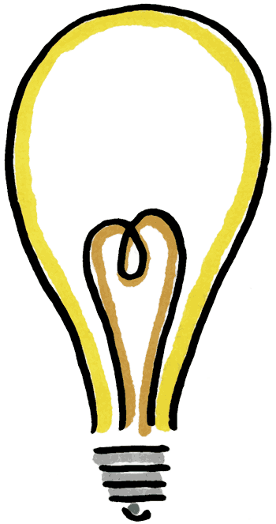
- Mastery: Our urge to become better in some area or skill. Challenge, mastery, and a sense of contribution are more motivating than successful fulfillment of any prescribed criteria.

- Purpose: We are more invested and creative when we are guided by a purpose. For example, Steve Jobs said his guiding purpose was to “make a Ding in the universe,” not money, not fulfill prescribed steps, but to make a “Ding,” and it’s clear that he has. What “Ding” will you make? What will be your purpose?
Genius Hour

What are our Learning Goals?
We are going to develop and practice a variety of skills as we each pursue a topic of our own interest. We will practice researching, note taking and synthesis of ideas, citation (always cite your sources), critical thinking, creativity, presentation skills, reading, writing, and digital literacy. We will use our blogs to share our learning throughout the course of our project. Also, we will share our completed work with the world through our webpages and blogs, in addition to being the genius that teaches the class what you learned, built, and created.

